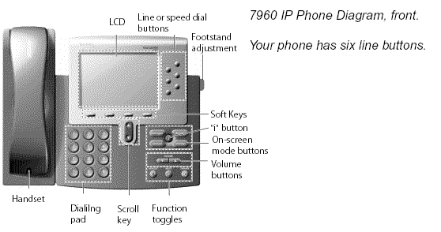

The Cisco IP telephone provides easy access to a wide range of business features.

SOFT KEYS
Features available based upon the state of your phone

TO PLACE A CALL

Internal
- Lift Handset, press the Speaker button, line button or the New Call soft key
- Dial the 4 Digit extension

External
- Lift Handset, press the Speaker button, line button or the New Call soft key
- Local – Dial 6 + Number
- Long Distance – Dial 6 + 1 + Number

LAST NUMBER REDIAL
- Press the REDIAL soft key

CALL FORWARD

To Activate
- When your phone is idle, press the CFWDALL soft key
- Enter the number, OR press MESSAGE key for sending calls directly to Voicemail

To Cancel
- Press the CFWDALL soft key

CALL HOLD

To Place a Call on Hold
- From an existing conversation, press the HOLD soft key

To Retrieve a Call on Hold
- Press the RESUME soft key

PICK UP
As a member of a Pickup Group
- When a phone is ringing within your group
- Press the MORE soft key until you see PICKUP
- Press the PICKUP button
- The call will ring on your phone with the Caller ID displayed.
- To accept the call, press the ANSWER soft key
- To ignore the call, press the IDIVERT soft key

CALL WAITING
- During a call a 2nd call is received.
- You will hear a call-waiting tone.
- Caller information will display on phone.
- Press ANSWER soft key to answer incoming call,
first call will automatically be placed on hold.

To resume back to first call

Scroll to first call and press RESUME.

TO TRANSFER A CALL
- During a call, press the TRANSFER soft key
- Dial the number
- Announce the call
- Press the TRANSFER soft key to complete the transfer, hang up

OR
- If the person you attempt to transfer the call to is not available, press the END CALL soft key and
then the RESUME soft key to return to the original caller

CONFERENCE CALL (maximum of 6)

While a call is in progress, press the MORE soft key and then press the CONFRN soft key. Dial the extension or outside number.
- After the party answers, press the CONFRN soft key to bring the parties together

To add additional parties
- Repeat the above steps
To reconnect to the Conference when a called party isn’t joining
- If the person you attempt to bring into the conference is not available, press the END CALL soft key and then the RESUME soft key to return to the conference call

To view the conference call members
- Press the MORE soft key, then press the CONFLI soft key to view the members on the conference call

MEET- ME CONFERENCE (maximum of 10)
HOST:
To establish a Meet Me conference
- Lift Handset, press the Speaker button, line button or the New Call soft key
- Press the MEET-ME soft key
- Dial the MEET-ME conference number
  - 3900 - 3909
- Communicate to Participants bridge information.

PARTICIPANT:

To Join a Meet-Me Conference
- Dial the MEET-ME conference number
You are now connected to the conference
- External callers may join by dialing the main number and dialing the Meet-Me extension from the automated attendant.

I-DIVERT

To immediately redirect a call to your coverage point
- While phone is ringing
- Press IDIVERT

JOIN
This feature allows you to join two incoming calls.

To answer the second incoming call
- Press the ANSWER soft key if it’s appropriate to place your first caller on hold (pressing this soft key automatically puts the first caller on hold)

To Join these two callers to create a 3-way call
- Scroll to the call that is on hold
- Press the MORE soft key
- Press the JOIN soft key

CALL PARK

To Park a Call
- On an existing call, press the MORE soft key and then the PARK soft key, the call is automatically placed into a park position, note the position in display of phone
- Park Range is: 3500 - 3529
- Hang Up

To Retrieve a Parked Call
- Dial the park position to which the call was parked, you are now connected
If the call is not picked up within 160 seconds, the call will ring back at parking extension.

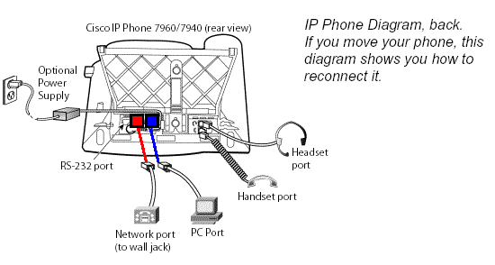

DIRECTORIES
- To view Missed, Received or Placed calls, press the DIRECTORIES button
- Scroll to the directory that you would like to view
- Press the SELECT soft key
- To place a call to one of the phone numbers from within the directory, press the DIAL soft key.

RING TYPE
- Press the SETTINGS button
- User Preferences
- Press Rings
- Select Line
- Use the scroll key to select a ring type
- Press the PLAY soft key to hear the ring type
- Press the SELECT soft key to save the ring type

LCD CONTRAST
- Press the SETTINGS button
- User Preferences
- Contrast/Display
- Use the UP and DOWN soft keys to change the contrast
- Press the OK soft key to save the setting

RING VOLUME
- With your phone idle, press the volume key to hear the current ring volume
- Press either the up or down volume key to change the ring volume
- When the ring times out, the setting will be saved

“I” INFORMATION BUTTON
- Press the ? button and then any other button on your phone to get information on how to use that button or key

VOICE MAIL SETUP AND ACCESS
To enroll with voice mail (first use)
- Press the Messages button
- Enter the first time enrollment
password = 986532
- Follow prompts to:
- Record your name - press # key as soon as you say your name
- Record a greeting – press # key as soon as you say your greeting
- Set a new password
Minimum length: ___6___
(Passwords will expire annually)

To log on to voice mail from your phone
- Press the Messages button or dial 4180.
- Enter your password, press the # key.

To log on to voice mail from another inside phone
- Press the Messages button or dial 4180.
- Press the * key when voice mail answers.
- Enter your ID (extension), then press # key.
- Enter your password, then press the # key.

To log on to voice mail from outside
- Dial the external voice mail phone number
260-982-4180
- Press the * key when voice mail answers
- Enter your ID (extension), then press # key.
- Enter your password, then press the # key.

Basic Controls
Press the Messages button and log on:

Hear new messages 1 Set up options 4
Send new message 2 Cancel or back up *
Review old messages 3 Skip or move ahead #

During Message Playback |  | After Message Playback
Restart message | 1 | Repeat | 1
Save | 2 | Save | 2
Delete  Slow Playback | 3  4 | Delete  Reply | 3  4
Change Volume | 5 | Forward message | 5
Fast Playback  Rewind, small | 6  7 | Save as new  Rewind | 67
Pause or Resume  Fast Forward, small | 8  9 | Play message summary | 9

**For Additional Feature Information and Menu Options review the Unity-At-A-Glance document

TRANSFER A CALLER INTO VOICEMAIL
- While connected to the caller, press the TRANSFER soft key,
- Press *
- Dial the person’s extension you are transferring the call to
- Press the TRANSFER soft key quickly

TO LEAVE A QUICK MESSAGE IN A MAILBOX WITHOUT CALLING THE EXTENSION:
- Pick up the handset
- Press * and the 5-digit extension
- Leave your message
- Hang up

