When working with our students or colleagues, thoughtful reminders:
To belong, we need to know:
- Am I important to someone here?
- Am I good at something here?
- Am I able to affect change or my world in here?
- Can I share my gifts with someone here?
Questions to ask:
- What do you need?
- How can I help?
- What can we do to make this better?
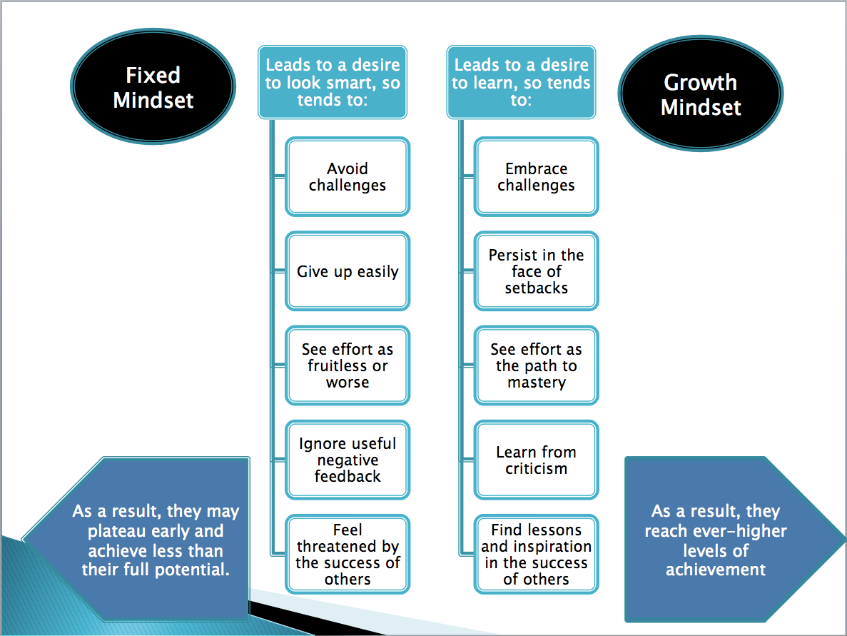
- What is getting in the way of this working for you?
Excerpt from: Katie Boucher, Ph.D. Indianapolis University
Excerpt from: Dr. Lori Desautles

