Spartan Alerts App for Web

From our experience, the InformaCast phone app represents the most intuitive way to maintain your contact information for alerts. You may find instructions to download and use the app here. However, if you don’t own a smartphone or just prefer the web, these instructions will demonstrate how to maintain your contact information, too.

If you have any questions, please contact University Safety by email at campussafety@manchester.edu.

Visit https://alerts.manchester.edu.

Enter your email address and click on the red arrow.

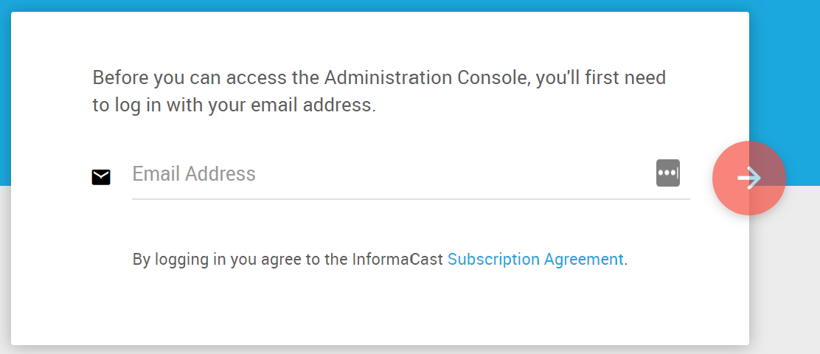

Log into Spartan Alerts using your MU credentials.

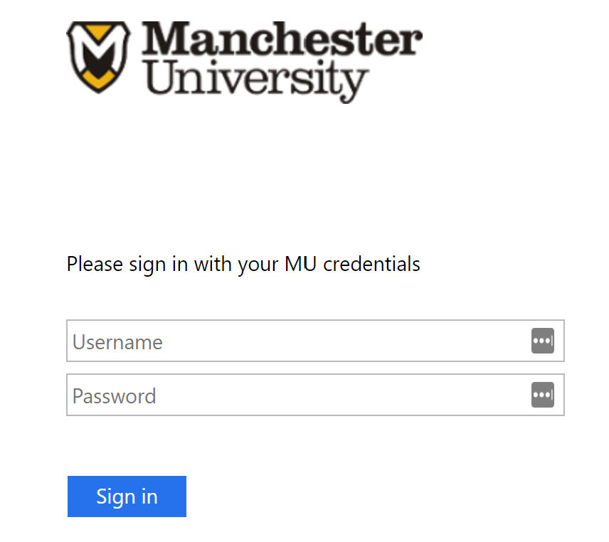

Click on your name in the upper left-hand corner and then click on Profile.

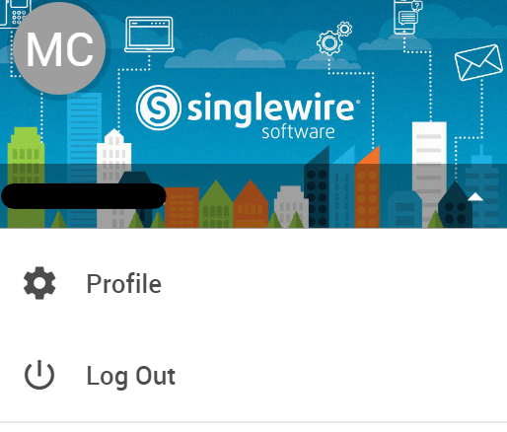

Add the information where you want to receive notifications. To do so, on the General tab click on the + sign in the upper right-hand corner of each section where you want to add information.

SMS represents those phone numbers that Spartan Alerts will text.

Phone Call represents those phone numbers that Spartan Alerts will call.

Email represents the email addresses where Spartan Alerts will email. You should find that we prepopulated your MU email address.

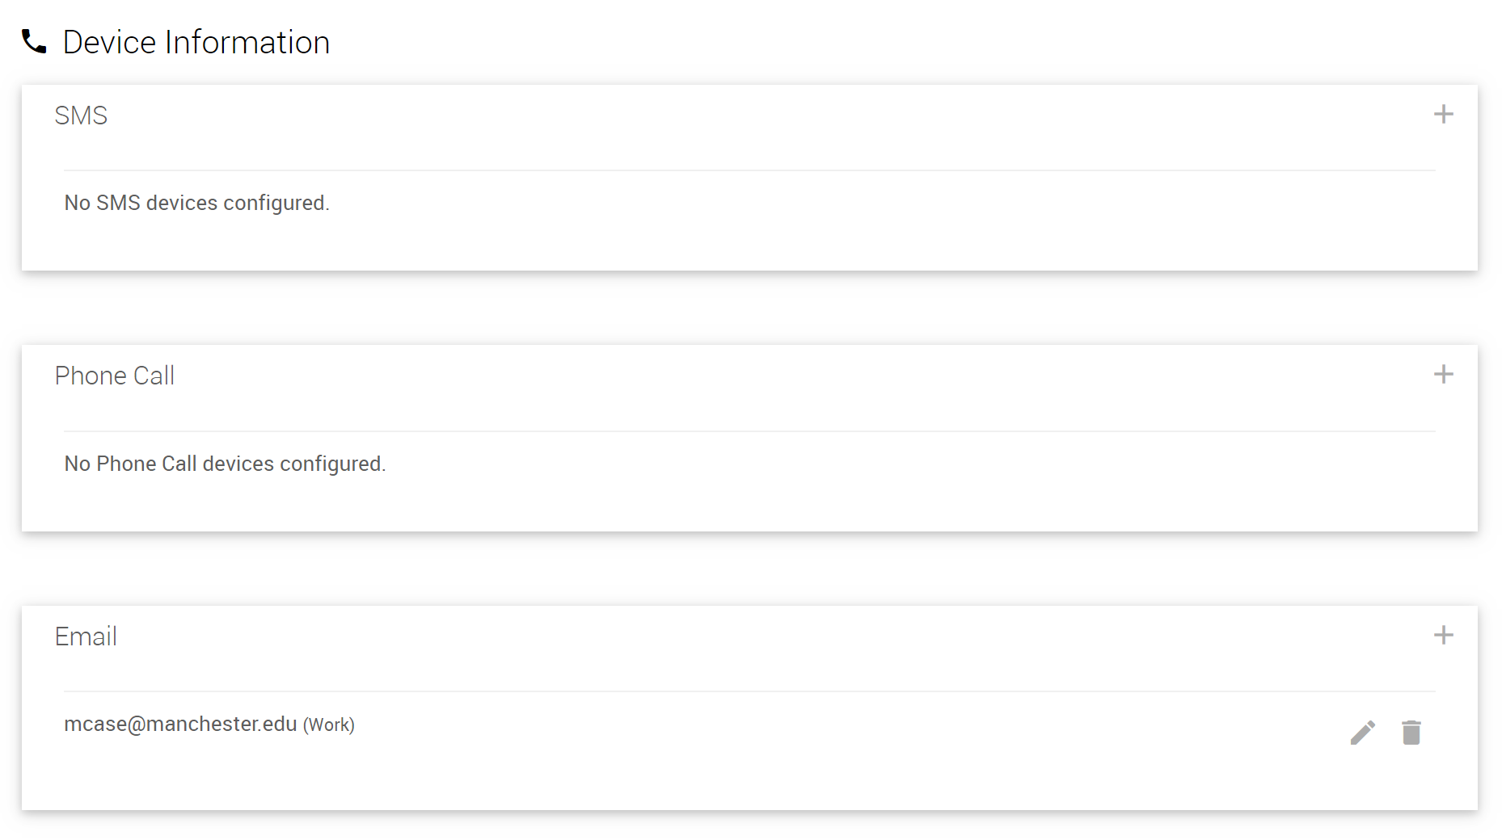

Add pertinent location information where you expect to be on the Locations tab. Add a location by clicking on the + sign in the User Locations section.

